Tailor-made by Rytons Enquiry Form

Please complete in as much detail as possible.

Company Name:
Contact Name:
Contact Number(s):
Email:
Project Name:
Brief description of the item(s) required:
Preferred Material:
Colour (if relevant):
Quantity:
Date Required:
Sketch (this will help us visualise your requirement):

Once completed please email to admin@rytons.com along with any accompanying information such as technical drawings, pdf plans etc. When received we will contact you for an initial discussion and prepare a quotation.

For Rytons use only:
Metal Finishes and Powder Coating Swatches

Self Colour Aluminium (SCA) | Anodised  Aluminium (AA) | Satin Anodised Aluminium (SAA) | Chrome Plate  (CP) | Satin Chrome Plate (SCP)
Polished Stainless Steel (PSS) | Satin Stainless  Steel (SSS) | Brass Anodised  (BA) | Polished Brass  (PB) | Imitation Bronze Metal Antique (IBMA)
Powder Coated:  RAL Colours | Powder Coated: Satin Black | 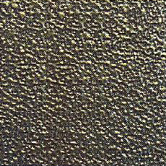  Powder Coated:  Textured Black | 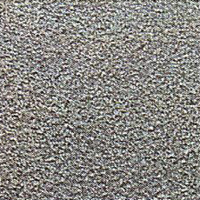  Powder Coated: Vintage Iron | 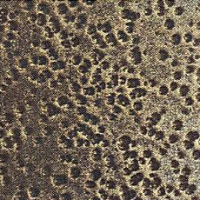  Powder Coated: Textured Iron
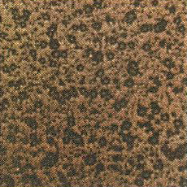  Powder Coated:  Aged Bronze | 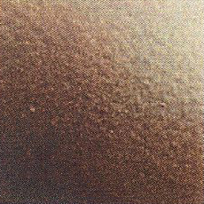  Powder Coated: Bronze Tone | Powder Coated: Burnished Bronze | Powder Coated: Espresso | Powder Coated: Textured Mocha
Powder Coated: Gold Vein | Please note: These swatches are for general guidance and should not be relied upon as the exact finish of the actual product. Colours on screen may vary depending on your screen settings and resolution.

